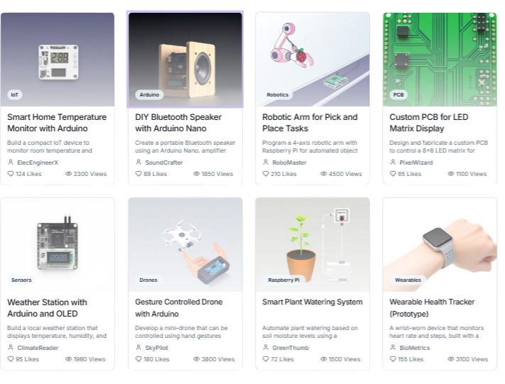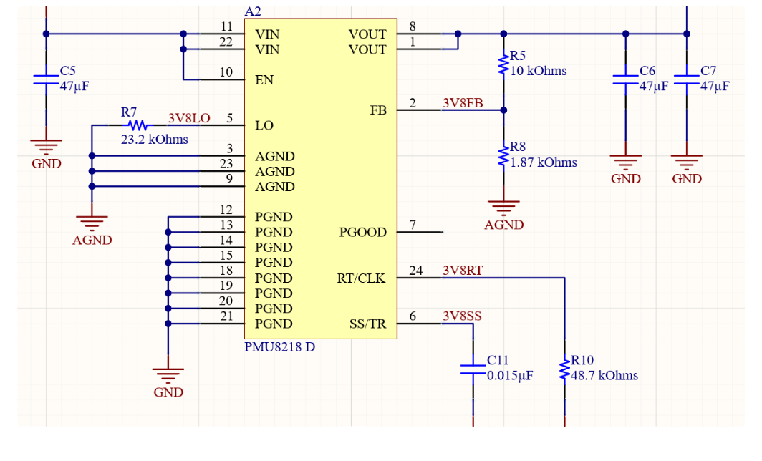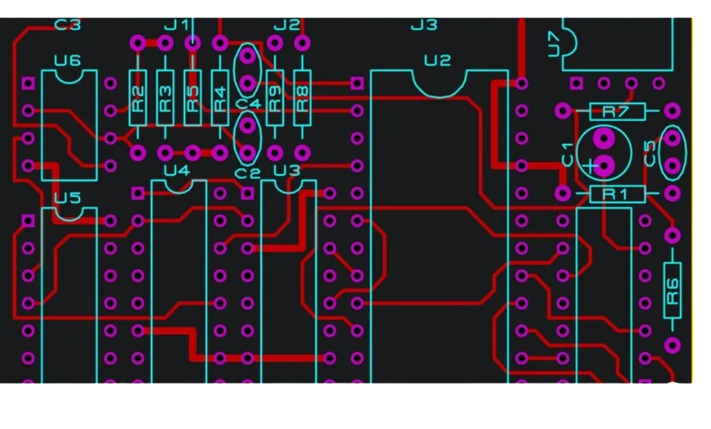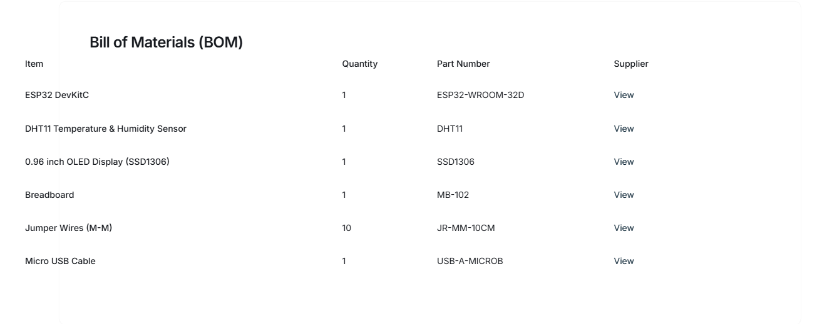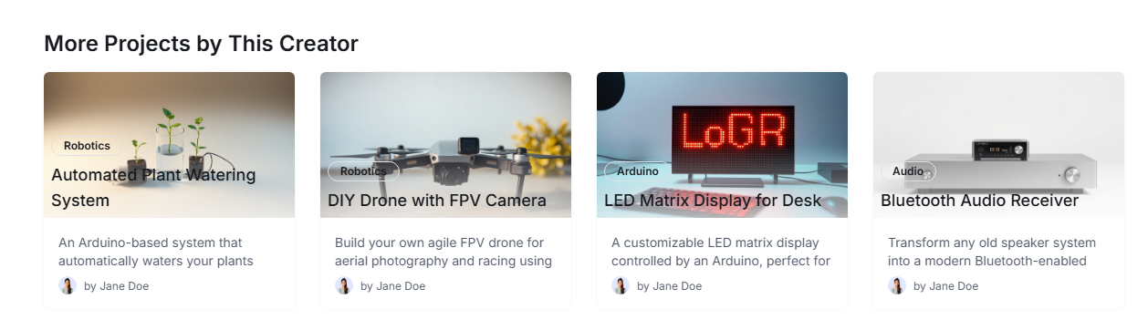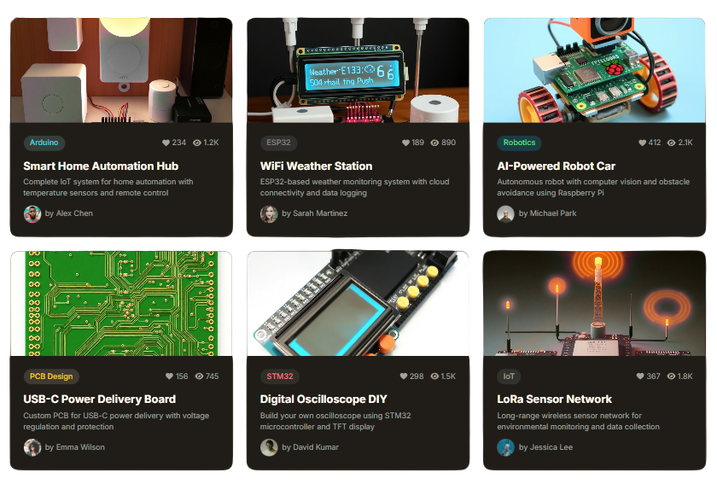
Let's create a digital prototype to map out the user interface of our website.
Wireframe Builder (Website)
Landing Page 1
PROJECT Showcase
VOLTARA P R O J E C T S
SEELCTED TAG ARDUINO CLEAR
Explore Projects
H E
2 0 2 5 V O L T A R A A L L R I G H T S R E S E R V E D
VOLTARA P R O J E C T S
Search Projects
SMART HOME AUTOMATION HUB
PROJECT DESCRIPTION
This project describes the design and implementation of a smart home temperature and humidity sensor using an ESP32 microcontroller and a DHT11 sensor. The data is transmitted wirelessly via Wi-Fi to a central hub, which can be integrated with popular smart home platforms like Home Assistant or Google Home. The system is designed for low power consumption, making it suitable for battery operation over extended periods. Key features include: - Real-time temperature and humidity monitoring. - Wi-Fi connectivity for data transmission. - Deep sleep mode for ultra-low power consumption. - Integration with smart home ecosystems. - Open-source hardware and software. The device also includes an OLED display for local readings and a tactile button to toggle display modes or initiate data re-sync. All components are readily available and the project aims to be accessible for hobbyists and experienced makers alike.
Schematic
PCB
VIEW ON GITHUB
2 0 2 5 V O L T A R A A L L R I G H T S R E S E R V E D
Terms & Conditions
© Voltara All Rights Reserved 2025
Social
Facebook Instagram Youtube
Twitter
Documentation
Help Centre Contact FAQ
Privacy Policy
Company
Home About Solutions Pricing Team
Career
VVoollttaarraa..
Stay in the loop and sign up for the Voltara newsletter:
Enter your email
Curated Collections
LEARN MORE
About Us
Voltara is dedicated to fostering innovation and collaboration in the open-source hardware community. We provide a platform for creators to share their projects, connect with like-minded individuals, and contribute to a future driven by open technology. Our mission is to democratize hardware development and make it accessible to everyone.
Featured Projects
Browse by Categories
Discover and Share Open- Source Hardware Projects
Voltara is the leading platform for makers, engineers, and hobbyists to collaborate on open-source hardware projects, share knowledge, and bring revolutionary ideas to life.
HOME EXPLORE ABOUT US

Search Projects

JOIN THE COMMUNITY
INDIVIDUAL PROJECT INFORMAITON

DELETE PROJECT

CREATE PROJECT

CREATE PROJECTS

EXPLORE PROJECTS
Search
Add notes or comments Add notes or comments Add notes or comments Add notes or comments

